Job title: | Carer Driver
Responsible to: | Team Leader / Shift Manager
Holiday/Sickness Relief: | Care Support Workers and Housekeepers

Purpose of the Job

- To promote and work within our values:
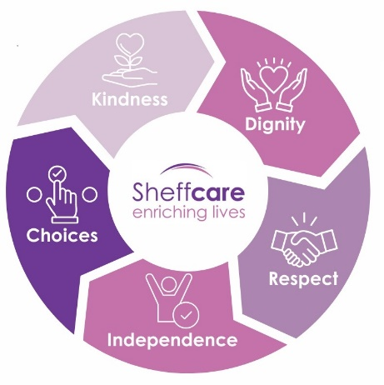
- To provide quality care to Residents to improve their quality of life.

- To provide transport services to Sheffcare homes, moving Residents and materials safely and efficiently

- To work within our Code of Conduct / Behaviour Charter.

Specific Duties & Responsibilities

- To be aware of and work within charity policies and procedures ensuring that all relevant legislation is implemented and followed.
- To provide individualised personal care for Residents based on their care plans, considering their physical, emotional, social, spiritual, and cultural needs.
- To help care for sick people, when necessary, which may involve coping with severe illness, dying and bereavement.
- To accompany Residents where necessary, to hospital, clinics and general practitioner appointments and associated services, including social activities.

- To drive light vans/mini buses transporting Residents and materials in a safe and efficient way. Ensure all passengers and materials are loaded safely and securely.

- To conduct routine checks on vehicles tyres, water and oil etc. reporting any faults to the Registered Manager / Deputy Manager.

- To maintain minimum fuel levels filling vehicle as necessary. Maintain vehicle log sheets.
- To tidy and clean Residents' personal space including the washing of chairs, commodes, wheelchairs and aids and adaptations as necessary.
- To make sure Residents' nutritional needs are met according to their care plan.
- To respect Residents' privacy and dignity while helping them stay independent and ensuring their confidentiality.
- To greet and deal with all visitors in a professional manner.
- To monitor and record security and safety of the home and the wellbeing of residents', to comply with charity policy.
- To understand and comply with fire precaution procedures and health and safety regulations.

- To buddy new staff.
- To participate in meetings, reviews, staff development and 1:1s as required within charity policies.
- To participate flexibly in rotas and routines as required by the charity
- To attend and fully participate in training as required by the charity.
- To perform any other tasks that fit your role.
- To keep accurate records and reports using the charity’s recording and information systems (PCS) as required.

- To complete any other reasonable tasks assigned by the management team

Person Specification

- Be adaptable to change
- Have a full, clean UK driving license
- Have experience in a similar role
- Have excellent observational skills
- Be able to build trust and rapport
- Be non-judgmental
- Have good time management and organisational skills
- Be willing to learn and develop
- Be approachable and able to connect and empathise with others
- Be able to use basic tech devices

This job description indicates only the main duties and responsibilities of the post. It is not intended as an exhaustive list.

I confirm I have received a copy of this job description

Name:

Signature:

Date:

